**Relative Strength Index – RSI**

By [James Chen](https://www.investopedia.com/contributors/101529/)

Updated May 16, 2019

Table of Contents

* [What Is Relative Strength Index?](https://www.investopedia.com/terms/r/rsi.asp#what-is-relative-strength-index--rsi)
* [The Formula for RSI](https://www.investopedia.com/terms/r/rsi.asp#the-formula-for-rsi)
* [Calculation of the RSI](https://www.investopedia.com/terms/r/rsi.asp#calculation-of-the-rsi)
* [What Does RSI Tell You?](https://www.investopedia.com/terms/r/rsi.asp#what-does-rsi-tell-you)
* [Divergences Example of RSI Use](https://www.investopedia.com/terms/r/rsi.asp#divergences-example-of-rsi-use)
* [RSI Swing Rejections Example](https://www.investopedia.com/terms/r/rsi.asp#rsi-swing-rejections-example)
* [RSI vs. MACD](https://www.investopedia.com/terms/r/rsi.asp#rsi-vs-macd)
* [Limitations Of The RSI](https://www.investopedia.com/terms/r/rsi.asp#limitations-of-the-rsi)

**What Is Relative Strength Index – RSI?**

The relative strength index (RSI) is a momentum indicator that measures the magnitude of recent price changes to evaluate overbought or oversold conditions in the price of a stock or other asset. The RSI is displayed as an oscillator (a line graph that moves between two extremes) and can have a reading from 0 to 100. The indicator was originally developed by J. Welles Wilder Jr. and introduced in his seminal 1978 book, *New Concepts in Technical Trading Systems.*

Traditional interpretation and usage of the RSI are that values of 70 or above indicate that a security is becoming overbought or [overvalued](https://www.investopedia.com/terms/o/overvalued.asp) and may be primed for a trend [reversal](https://www.investopedia.com/terms/r/reversal.asp) or corrective [pullback](https://www.investopedia.com/terms/p/pullback.asp) in price. An RSI reading of 30 or below indicates an oversold or [undervalued](https://www.investopedia.com/terms/u/undervalued.asp) condition.

**Key Takeaways**

* The RSI is a popular momentum oscillator developed in 1978.
* The RSI compares bullish and bearish price momentum plotted against the graph of an asset's price.
* Signals are considered overbought when the indicator is above 70% and oversold when the indicator is below 30%.

**The Formula for RSI**

The relative strength index (RSI) is computed with a two-part calculation that starts with the following formula:

RSIstep one=100−[1001+Average gainAverage loss]RSI_{\text{step one}} = 100- \left[ \frac{100}{ 1 + \frac{\text{Average gain}}{\text{Average loss} }} \right]RSIstep one​=100−[1+Average loss

Average gain​

100​]﻿

The average gain or loss used in the calculation is the average percentage gain or losses during a look-back period. The formula uses positive values for the average losses.

The standard is to use 14 periods to calculate the initial RSI value. For example, imagine the market closed higher seven out of the past 14 days with an average gain of 1%. The remaining seven days all closed lower with an average loss of -0.8%. The calculation for the first part of the RSI would look like the following expanded calculation:

55.55=100−[1001+(1%14)(0.8%14)]55.55 = 100- \left[ \frac{100}{ 1 + \frac{ \left( \frac{1\%}{14} \right) }{ \left( \frac{0.8\%}{14} \right) }} \right]55.55=100−⎣⎢⎡​1+(14

0.8%​)(141%​)​

100​⎦⎥⎤​﻿

Once there are 14 periods of data available, the second part of the RSI formula can be calculated. The second step of the calculation smooths the results.

RSIstep two=100−[1001+Previous average gain∗13+Current gainAverage average loss∗13+Current loss]RSI_{\text{step two}} = 100- \left[ \frac{100}{ 1 + \frac{ \text{Previous average gain}*13 + \text{Current gain} } {\text{Average average loss}*13 + \text{Current loss} } } \right]RSIstep two​=100−[1+Average average loss∗13+Current loss

Previous average gain∗13+Current gain​

100​]﻿

**Calculation of the RSI**

1:29

**Relative Strength Index (RSI)**

Using the formulas above, RSI can be calculated, where the RSI line can then be plotted alongside an asset's price chart.

The RSI will rise as the number and size of positive closes increase, and it will fall as the number and size of losses increase. The second part of the calculation smooths the result, so the RSI will only near 100 or 0 in a strongly [trending market](https://www.investopedia.com/terms/t/trending-market.asp).

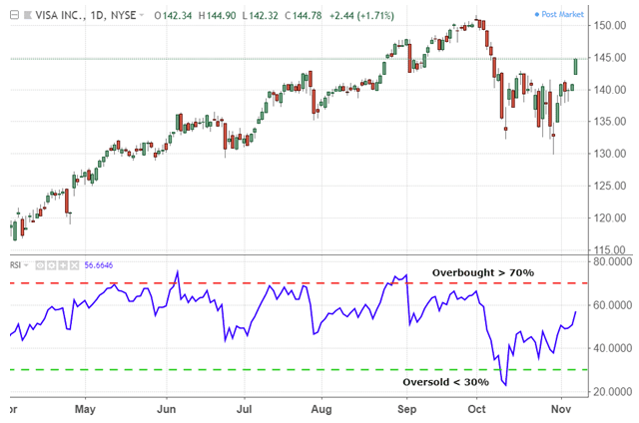

TradingView.

As you can see in the above chart, the RSI indicator can remain in "overbought" territory for extended periods while stock is in an [uptrend](https://www.investopedia.com/terms/u/uptrend.asp). The indicator can stay in "oversold" territory for a long time while stock is in a [downtrend](https://www.investopedia.com/terms/d/downtrend.asp). This can be confusing for new analysts, but learning to use the indicator within the context of the prevailing [trend](https://www.investopedia.com/terms/t/trend.asp) will clarify these issues.

**What Does RSI Tell You?**

The primary trend of the stock or asset is an important tool in making sure the indicator's readings are properly understood. For example, well-known market technician Constance Brown, CMT, has promoted the idea that an oversold reading on the RSI in an uptrend is likely much higher than 30%, and an overbought reading on the RSI during a downtrend is much lower than the 70% level.

As you can see in the following chart, during a downtrend, the RSI would peak near the 50% level rather than 70%, which could be used by investors to more reliably signal bearish conditions. Many investors will apply a horizontal [trendline](https://www.investopedia.com/terms/t/trendline.asp) that is between 30% or 70% levels when a strong trend is in place to better identify extremes. Modifying overbought or oversold levels when the price of a stock or asset is in a long-term, [horizontal channel](https://www.investopedia.com/terms/h/horizontalchannel.asp) is usually unnecessary.

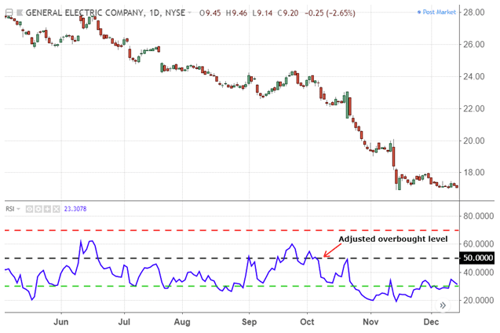

TradingView.

A related concept to using overbought or oversold levels appropriate to the trend is to focus on [trading signals](https://www.investopedia.com/terms/t/trade-signal.asp) and techniques that conform to the trend. In other words, using bullish signals when the price is in a bullish trend and bearish signals when a stock is in a bearish trend will help to avoid the many false alarms the RSI can generate.

**Divergences Example of RSI Use**

A bullish [divergence](https://www.investopedia.com/terms/d/divergence.asp) occurs when the RSI creates an oversold reading followed by a higher low that matches correspondingly lower lows in the price. This indicates rising bullish momentum, and a break above oversold territory could be used to trigger a new [long position](https://www.investopedia.com/terms/l/long.asp).

A bearish divergence occurs when the RSI creates an overbought reading followed by a lower high that matches corresponding higher highs on the price.

As you can see in the following chart, a bullish divergence was identified when the RSI formed higher lows as the price formed lower lows. This was a valid signal, but divergences can be rare when a stock is in a stable long-term trend. Using flexible oversold or overbought readings will help identify more valid signals than would otherwise be apparent.

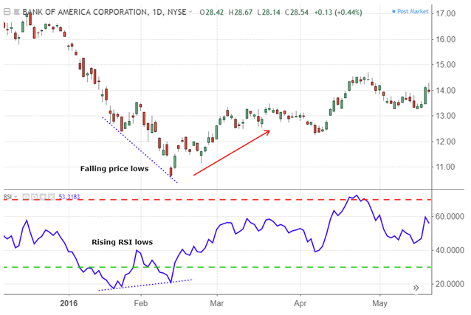

TradingView.

**RSI Swing Rejections Example**

Another trading technique examines the RSI's behavior when it is re-emerging from overbought or oversold territory. This signal is called a bullish "swing rejection" and has four parts:

1. RSI falls into oversold territory.
2. RSI crosses back above 30%.
3. RSI forms another dip without crossing back into oversold territory.
4. RSI then breaks its most recent high.

As you can see in the following chart, the RSI indicator was oversold, broke up through 30% and formed the rejection low that triggered the signal when it bounced higher. Using the RSI in this way is very similar to drawing trendlines on a price chart.

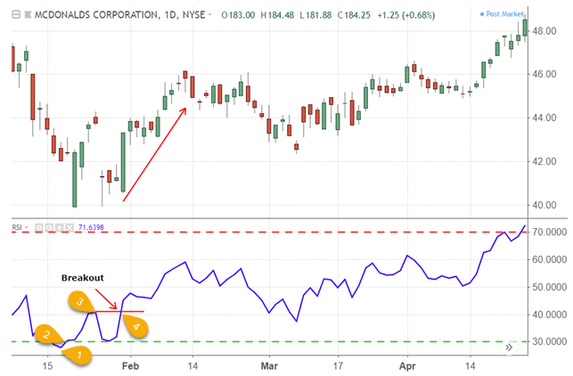

TradingView.

Like divergences, there is a bearish version of the swing rejection signal that looks like a mirror image of the bullish version. A bearish swing rejection also has four parts:

1. RSI rises into overbought territory.
2. RSI crosses back below 70%.
3. RSI forms another high without crossing back into overbought territory.
4. RSI then breaks its most recent low.

The following chart illustrates the bearish swing rejection signal. As with most trading techniques, this signal will be most reliable when it conforms to the prevailing long-term trend. Bearish signals in negative trends are less likely to generate a false alarm.

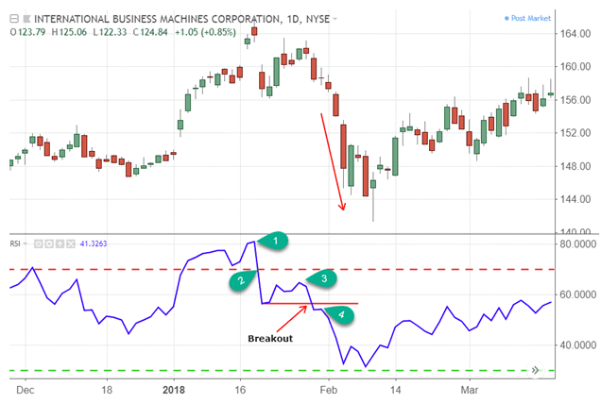

TradingView.

**RSI vs. MACD**

The [Moving Average Convergence Divergence](https://www.investopedia.com/terms/m/macd.asp) (MACD) is another trend-following momentum indicator that shows the relationship between two moving averages of a security’s price. The MACD is calculated by subtracting the 26-period [Exponential Moving Average](https://www.investopedia.com/terms/e/ema.asp) (EMA) from the 12-period EMA. The result of that calculation is the MACD line. A nine-day EMA of the MACD called the "signal line," is then plotted on top of the MACD line, which can function as a trigger for buy and sell signals. Traders may buy the security when the MACD crosses above its signal line and sell, or short, the security when the MACD crosses below the signal line.

The RSI aims to indicate whether a market is considered to be [overbought](https://www.investopedia.com/terms/o/overbought.asp) or [oversold](https://www.investopedia.com/terms/o/oversold.asp) in relation to recent price levels. The RSI calculates average price gains and losses over a given period of time; the default time period is 14 periods with values bounded from 0 to 100.

The MACD measures the relationship between two EMAs, while the RSI measures price change in relation to recent price highs and lows. These two indicators are often used together to provide [analysts](https://www.investopedia.com/terms/a/analyst.asp) a more complete technical picture of a market.

These indicators both measure momentum in a market, but because they measure different factors, they sometimes give contrary indications. For example, the RSI may show a reading above 70 for a sustained period of time, indicating a market is [overextended](https://www.investopedia.com/terms/o/overextension.asp) to the buy side in relation to recent prices, while the MACD indicates the market is still increasing in buying momentum. Either indicator may signal an upcoming trend change by showing divergence from price (price continues higher while the indicator turns lower, or vice versa).

**Limitations Of The RSI**

The RSI compares bullish and bearish price momentum and displays the results in an oscillator that can be placed alongside a price chart. Like most technical indicators, its signals are most reliable when they conform to the long-term trend. True reversal signals are rare and can be difficult to separate from false alarms. A false positive, for example, would be a bullish crossover followed by a sudden decline in a stock. A false negative would be a situation where there is a bearish crossover, yet the stock accelerated suddenly upwards.

Since the indicator displays momentum, as long as an asset's price momentum remains strong (either up or down) the indicator can stay in overbought or oversold territory for long periods of time. Therefore, the RSI is most trustworthy in an oscillating market when the price is alternating between bullish and bearish periods.